**INFORMATIONAL SUPPORT FOR COASTAL FORECAST DEVELOPMENT OF RUSSIAN TIDELESS SEAS**

***Kosyan Maxim, National Research Nuclear University MEPhI,*** [***mkosian19@gmail.com***](mailto:mkosian19@gmail.com)

**Abstract. The goal of the accomplished work was provision of information to the project, targeted at study of forming and evolution processes of accumulative shore forms of tideless seas of Russia under the effect of hydro-, litho- and morphodynamic factors. Project is accomplished by a team of specialists from leading Russian research institutions from year 2014 onwards. Main element of saving research results is information-analytical complex, which is found on the Internet at http://cofore.coastdyn.ru/index_eng.html, consists of static and dynamic modules, system of statistical analysis and management and protection of created resources. Information sources for information-analytical complex consists of: existing databases of reference data from Institute of Oceanology, material gathered from long distance and on-site observations over dynamic of coastal waters and sedimentary transportation; material from conferences and open publications. As project develops it is planned to keep developing complex with new research data and relevant publications.**

*Key words: website, coastal accumulative forms, informational support, forecast.*

1. **Introduction**

The project follows and develops the research of many years on formation and evolution of coastal accumulative forms under hydro- litho- and morphodynamic exposure and their response on environmental changes by a team from P.P.Shirshov Institute of Oceanology RAS. The research object is chosen because of negative natural and anthropogenic impact on current state and undetermined future of coastal zones. The planned research is of current importance for there is no elaborated methodic of comprehensive investigation of coastal accumulative bodies as a whole including relative contribution assessment of all natural and anthropogenic processes responsible for sea coasts transformation. The accumulative coastal systems representing a considerable part of the coast-line of tideless Russian seas undergo the fastest and large-scale changes. In this connection a scientifically substantiated forecast of natural and anthropogenic impact on the sea coasts and criteria of coastal zone vulnerability based on modern knowledge are of crucial importance for solution of not only fundamental but practical and social problems. Thereby an analysis of the current state of all components of tideless Russian sea coastal systems is an urgent need. The central aim of the project is a forecasting of tideless Russian accumulative sea coasts evolution based on new data on formation and temporal and spatial variability of coastal accumulative systems subject to changeable environmental conditions. It will be reached in a form of a comprehensive research including field, distant, analytical methods, long-term monitoring data and mathematical modeling of hydro- and lithodynamic processes.

1. **Website structure**

The **main page** contains core project information such as knowledge branch and classification codes, as well as list of most recent changes on the website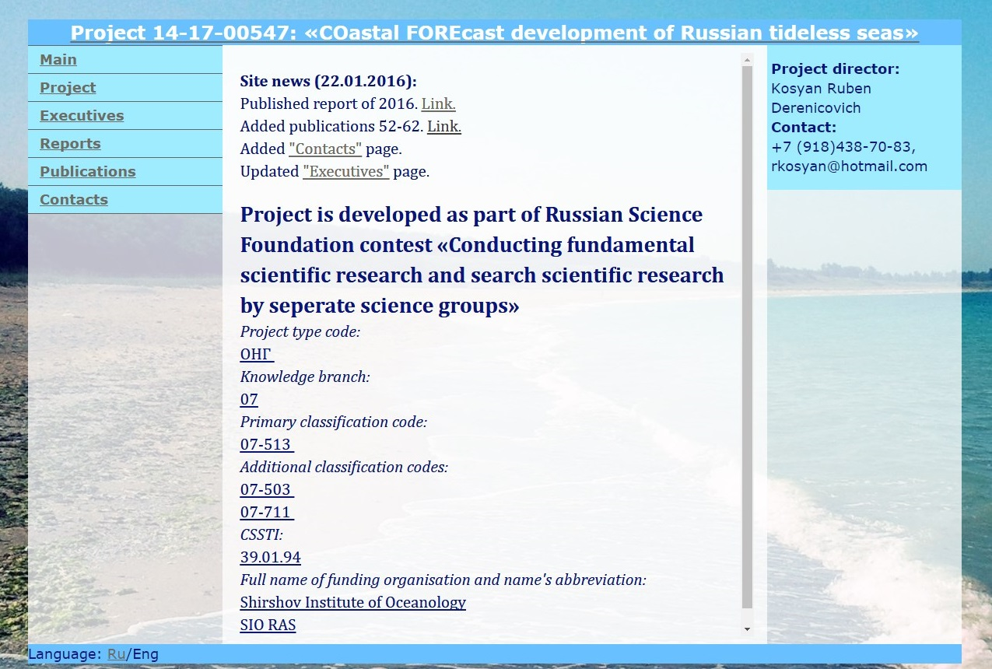

The **project** page contains more conclusive data about the project, its area of research, its goals.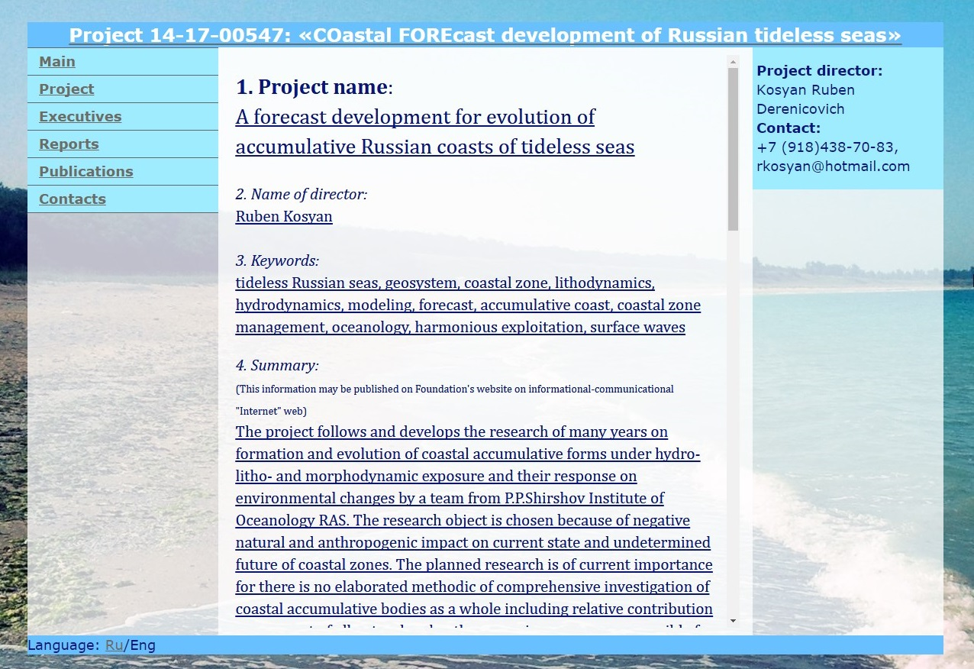

The **“executives”** page contains the list of all the people working on the project.

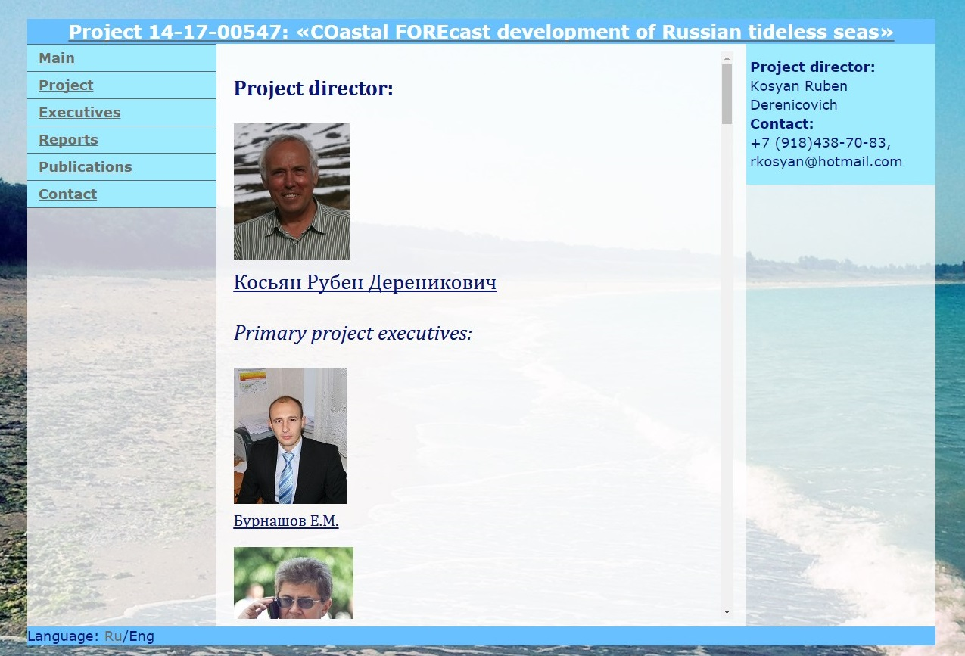

Achieved results for each year are published on **“Reports”** page.

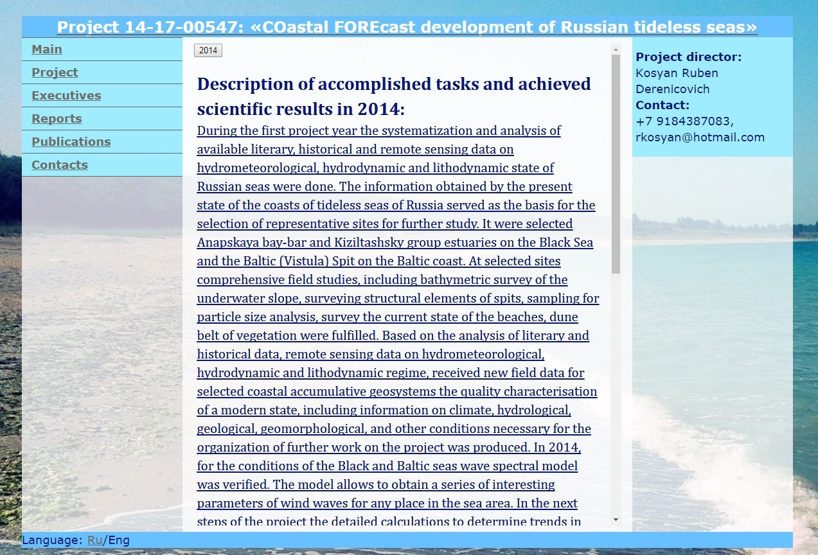

Various articles written by project members can be found on **“Publications”** page.

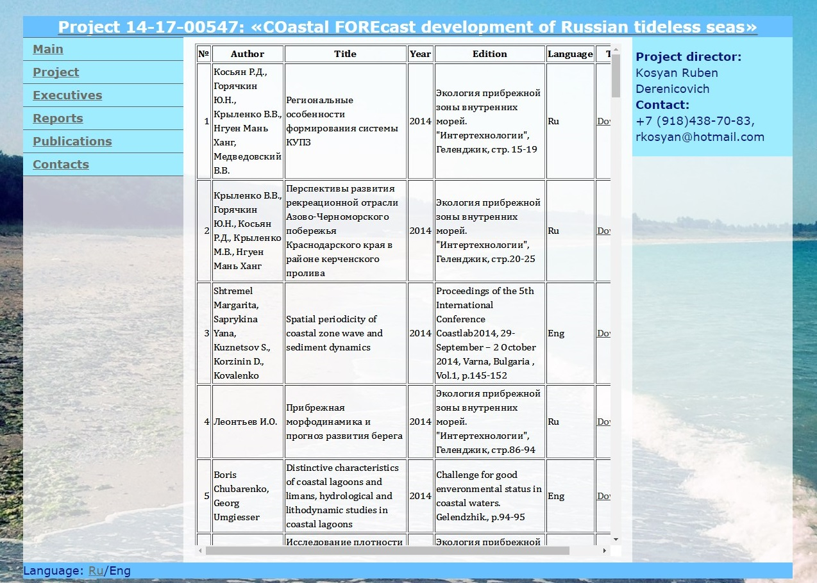

1. **Database upkeep**

The website database is being moderated remotely. All of website contents are protected, with direct access being available only to administrator, as well as backed up and saved on multiple machines in case of emergency, all of which ensures stability of the website and safety of its contents.

1. **Project results**

**Results of 2014:**

1) Selected the most representable regions for commencing detailed research.

2) Determined the set of parameters, data and materials required for further research.

3) Chosen the methods of acquiring and processing field data that allows comparison of new results to data of preceding research, forming following year expedition schedule.

4) Picked technical requirements for requested data of long distance probing, mathematic modeling, and other required research.

5) Conducted model calculations using data from natural measurements.

Project results over the first year were presented on 11 international conferences. 2 studies and over 30 articles were published.

**Results of 2015:**

1) From chosen regions (Vistula Spit and Anapa spit), approximately 400 samples of coastal and underwater sediment were acquired and processed. Sea operations were undertaken on over 500 km, length of land observations and geodetic profiling is approximately 150 km.

2) Acquired cartographic material and long distance probing data with required spectral characteristics and resolution. This data were processed and needed information were received.

3) Via analytic and lab processing of work and droning results, received a number of numeric parameters necessary for verifying mathematic models of forecast of developments in selected regions

4) Based on acquired data, developed qualifying and quantifying characteristics of main natural and technological processes which influence the present state and transformation speed of accumulated bodies within testing areas.

5) Using fund and literature data developed a newest model of tectonics of selected regions and their adjacent territories, composed neo-tectonic forecast of short-term and long-term developments of these accumulated forms.

6) Improved the accuracy of mathematical models characteristics, received necessary parameters and criteria, verified models according to new data of hydrological, morphometric, granulometric and other parameter measurements.

In this year, 12 information-analytical articles were published in leading scientific magazines, 16 articles in various anthologies. Two articles are accepted for printing. 27 reports were submitted on 14 international conferences and forums.

A more expanded report, schedule for the next project year and all publications mentioned above have been published on oceonological database at <http://cofore.coastdyn.ru/>.

1. **Further developments**

As the project continues research and development, all the results, changes and publications will be recorded in the website database. In addition, there are plans on expanding the site with new types of data, such as more detailed measurements and calculations, images and maps related to the project, search engine corresponding to publications. Naturally, this resource will continue to be moderated, to ensure its upkeep and continuity.

1. **Acknowledgement**

The present paper appeared due to the support of the Russian Scientific Foundation (RSF, project no. 14-17- 00547). Author wants to express his personal sincere gratitude to Igor Podymov for providing domain space to host the website and continuous help and support during the work on it.